**Application Development Documentation- Ladbrokes**

17

**Project Documentation**

**Programming Project - NEXT 5**

**Maurice Keightley**

# 1.0 Why I have chosen this approach?

## 1.1Approach to retrieving Ladbrokes Data

Before I began this project – I analysed the current Ladbrokes website and analysed their current top 5 races module. This provided a clear vision of what was required and how to achieve it.

Due to my experience with API’s – my first approach was to apply for access to the Ladbrokes API to retrieve the data for the races. The reason why I didn’t do this was because you needed to register a company name and obey the gambling licence requirements.

Another approach was to use the current Ladbrokes website and retrieve static html directly. By using the IDs and html tags as hierarchy reference points – was able to store the values in an array. This was completed in a PHP script.

By using AJAX post/get requests – was able to send data from User client to the server scripts which could then retrieve data.

I also include a bootstrap theme with built styles to improve the user experience and give the website a nice look. Unfortunately I was not able to complete the look and functionality I desired.

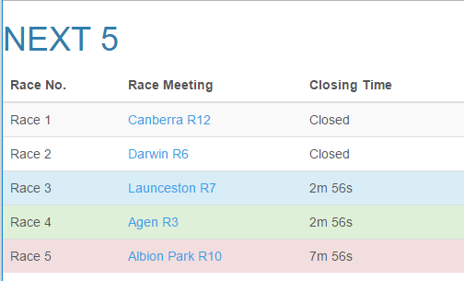

Figure 1Main Index Screen

## 1.2 Approach in choosing platform

It is clear that a Model View Controller layout would be best for this scenario, as the application would need to collect the data from input, manipulate the data and display it to the screen in an efficient and effective way. Using PHP, it allowed the future possibility of data population and manipulation through databases and other. The included JavaScript allows a usable/friendly experience to the client.

## 1.3 Approach in coding validation

Some validation was added to ensure data was accurate – using regular expressions and check statements. However I strongly believe there could have been more data testing with given scenarios, user test plans and more. These features will be incorporated in the next version.

## 1.4 Next 5 Version 1.1 Upgrades

* All data would be saved in a Database on Server
* Race gates will be display on screen for participant
* Easy to use buttons will be used on main page instead of links.
* Pictures on main page and more website user interface will be more enhanced.
* Track conditions and race results will be display to screen.